Splunk Search Language (SPL) -Basic Detection Queries
Analyst: Idris Ibrahim Adetola
Date: 17-12-2025

Overview
This report documents the development and validation of three Splunk Processing Language (SPL) queries designed to identify suspicious file creation, process execution, and network communication activity within Sysmon logs. The goal is to demonstrate basic detection engineering skills, noise reduction techniques, and investigative workflows used in a SOC environment.
I performed basic log analysis using Splunk Processing Language to identify suspicious process creation, network connections and suspicious file creation.
- Query 1: Suspicious file creation
index=main sourcetype=_json EventID=11
| eval Target=lower(TargetFilename)
| where (like(Target, "%\\temp\\%") AND (like(Target,"%.exe") OR like(Target,"%.dll")))
| where NOT like(Target,"%\\program files\\%")
| where NOT like(Target,"%\\windows\\%")
| table _time, user, computer, TargetFilename, Image, ProcessID
|sort _time

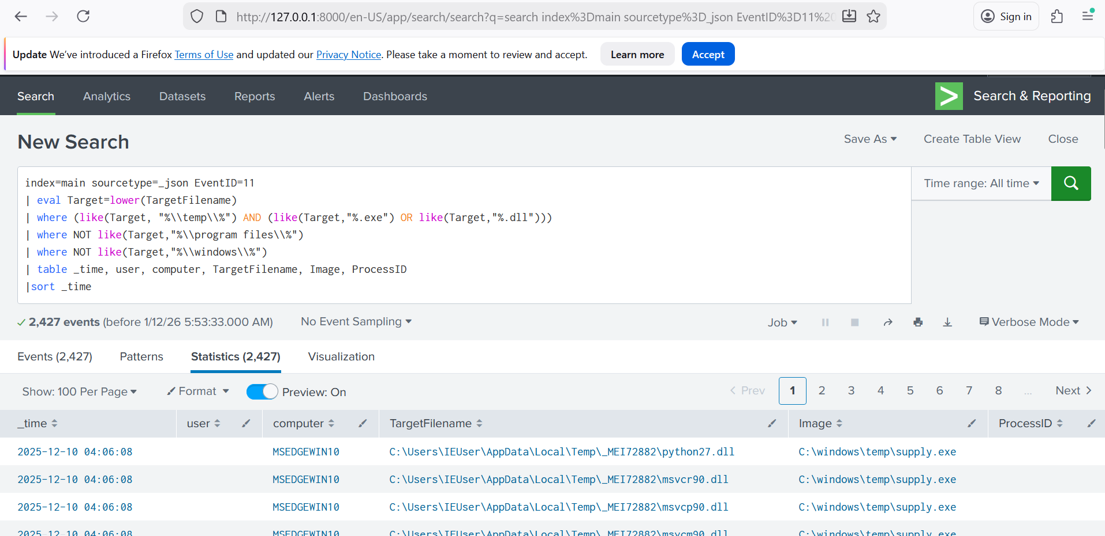

Explanation:
Line 1 searches the main index and filter for EventID = 11, which is sysmon File Create ID
Line 2 creates a new field called Target and converts the existing TargetFilename field to lowercase to avoid missing matches due to capitalization.
Line 3 filters file that was created in the Temp directory and ends with either .exe or .dll
Line 4 and 5 reduces noise by excluding benign paths from the search.
Line 6 outputs the results of the search in a table form specifying the necessary fields
Line 7 sorts the outputs by time of events.

- Query 2: Suspicious Process Creation
index=main sourcetype=_json EventID=1 Image IN ("*powershell.exe", "*cmd.exe", "*wscript.exe", "*cscript.exe")
| eval PI = lower(ParentImage), PC=lower(ParentCommandLine)
|eval score=0
|eval score=score + if(like(PI,"%\\Downloads\\%") OR like(PI,"%\\temp\\%"),1,0)
|eval score=score + if(like(PC,"%powershell%") OR like(PC,"%cmd.exe%") OR like(PC,"%wscript%") OR like(PC,"%cscript%"),1,0)
|where score >= 1
|table _time,host, user, Image, ParentImage, ProcessId, ParentProcessId, ParentCommandLine, score
|sort _time

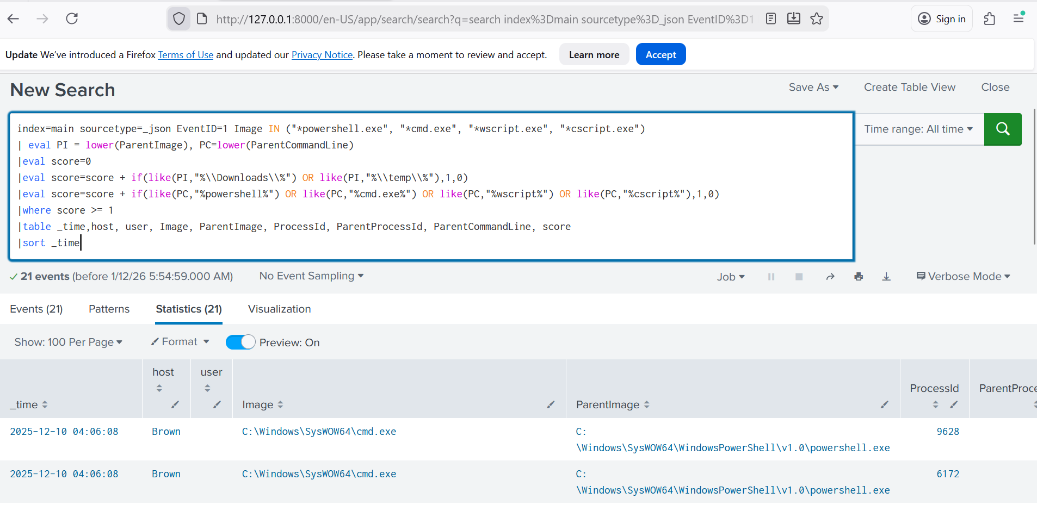
Explanation:
Line 1 searches the main index, filter for event ID=1; which is sysmon process creation ID. Then search the Image field for processes powershell,cmd,wscript and cscript. Which are common scripting and commandline tools mostly abused by attackers.
Line 2 creates new fields PI and PC which convert Parent image and ParentcommandLine field to lowercase respectively. This ensures that the search strings are case insensitive.
Line3 creates a new numeric field “score=0” which starts all events at zero. It will be used as a simple risk-scoring mechanism
Line4, add one point if the parent process came from a Downloads folder OR Temp directory. Otherwise, add 0
Line5, add one point if the parent command Line field contains keywords powershell,cmd.exe,wscript or cscript. Otherwise, add 0.
Line 6 filter by risk score i.e keep events that score more at least 1. That means one suspicious behaviour was detected.
Line 7 displays the result in table format with relevant fields.
Line 8 sorts the results by time.

- Query 3: Network Connections By IP
index=main sourcetype=_json EventID=3
| stats count by destinationIp
| sort - count
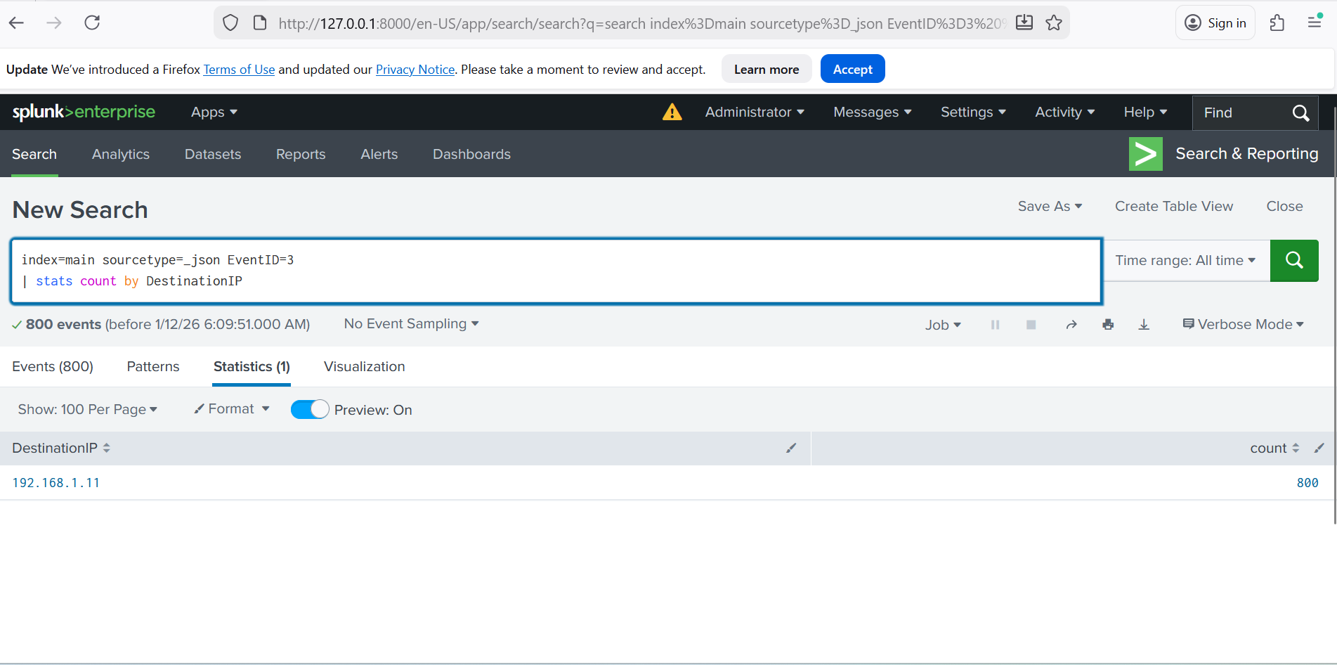
Explanation
This query aggregates network connection events by destination IP and sorts them by frequency to identify potential Command-and-Control (C2) infrastructure, beaconing behavior, or abnormal outbound traffic patterns .

